ASSIGNMENT- 7 (DBMS LAB)

* **PROBLEM -** Create a table named employee, works , company, manages as the following:
* **PROGRAM -**

create table employee_91(emp_id int primary key, emp_name varchar(30), street varchar(30), city varchar(30));

create table works_91(emp_id int primary key, emp_name varchar2(30), company_name varchar2(30), salary varchar2(30));

create table company_91(emp_id int primary key, emp_name varchar2(30), company_name

varchar2(30), city varchar2(30));

create table manages_91(emp_id int primary key, emp_name varchar2(30), manegers_name varchar2(30));

* **OUTPUT :** Table created.
* **PROGRAM:**  describe employee_91;
* **OUTPUT :**

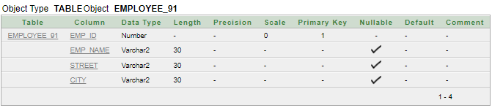

describe works_91;

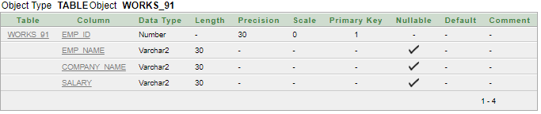

describe company_91;

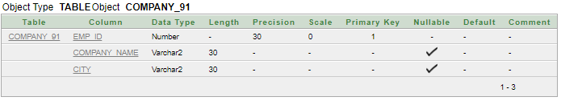

describe manages_91;

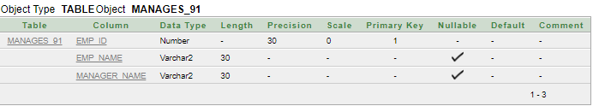

* **PROGRAM:-**

Begin

insert into employee_91 values(1,'SUUMAN DHARA','NH12','HOWRHA');

insert into employee_91 values(2, 'MD HUMAYUN KABIR','NH12','kolkata'); insert into employee_91 values(3, 'PRABIN','NH23','barasat');

insert into employee_91 values(4, 'MD AZAD','NH12','kolkata');

insert into employee_91 values(5, 'Tanya RAJ','NH3','HOWRHA');

insert into employee_91 values(6, 'RAJASHRI MONDAL','NH1','kazipara');

insert into employee_91 values(7,'NIKITA','NH12','kolkata');

insert into employee_91 values(8, 'KK RAJ','NH120','jalpaiguri');

insert into employee_91 values(9, 'SUMIT RAJ','NH12','kolkata');

insert into employee_91 values(10, 'VIKRAM','NH23','dumdum');

insert into employee_91 values(11, 'POOJA','NH12','kolkata');

insert into employee_91 values(12, 'MOHIT','NH15','sealdah');

insert into employee_91 values(13, 'LOVE YOU','NH22','barakpur');

insert into employee_91 values(14, 'UNDERTAKER','NH12','kolkata');

insert into employee_91 values(15, 'STEVEN','NH22','murshidabad');

insert into employee_91 values(16,'CRISTAINO','NH23','madhuabani');

insert into employee_65 values(17, 'MAMTA DIDI','NH21','patna');

insert into employee_91 values(18, 'MODI','NH60','patna');

insert into employee_91 values(19, 'INDIAN ARMY','NH12','kolkata');

insert into employee_91 values(20, 'ISITA RAJ','NH12','kolkata');

end

SELECT * FROM EMPLOYEE_91;

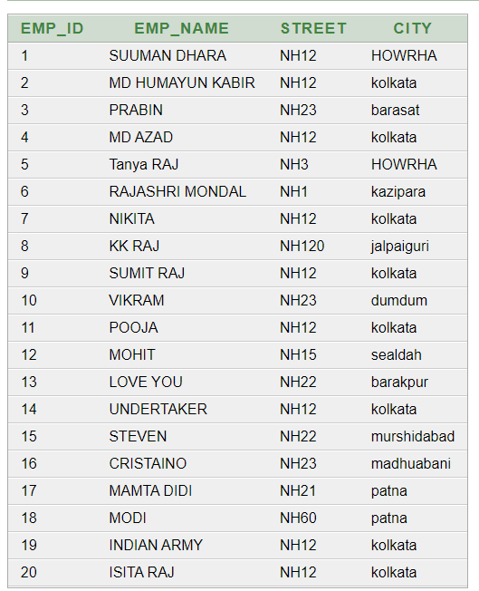

begin

insert into works_91 values(1, 'SUMAN DHARA','FIRST BANK CORPORATION','18000');

insert into works_91 values(2, 'MD HUMAYUN KABIR','SMALL BANK CORPORATION','14500');

insert into works_91 values(3, 'PRABIN','GRAMIN BANK CORPORATION','28000');

insert into works_91 values(4, 'MD AZAD','FARMER BANK','45000');

insert into works_91 values(5, 'Tanya RAJ','FIRST BANK CORPORATION','56000');

insert into works_91 values(6, 'RAJASHRI MONDAL','SMALL BANK CORPORATION','23000');

insert into works_91 values(7, 'NIKITA','SMALL BANK CORPORATION','45000');

insert into works_91 values(8, 'KK RAJ','FIRST BANK CORPORATION','21000');

insert into works_91 values(9, 'SMIT RAJ','SMALL BANK CORPORATION','23900');

insert into works_91 values(10, 'VIKRAM','FARMER BANK','67000');

insert into works_91 values(11, 'POOJA','FIRST BANK CORPORATION','23145');

insert into works_91 values(12, 'MOHIT','SMALL BANK CORPORATION','20000');

insert into works_91 values(13, 'LOVE YOU','BANK OF WORLD','52000');

insert into works_91 values(14, 'UNDERTAKER','FIRST BANK CORPORATION','25000');

insert into works_91 values(15, 'STEVEN','BANK CORPORATION','47000');

insert into works_91 values(16, 'CRISTAINO','BANK OF WORLD','56000');

insert into works_91 values(17, 'MAMTA DIDI','FIRST BANK CORPORATION','23000');

insert into works_91 values(18, 'MODI','GRAMIN BANK CORPORATION','8900');

insert into works_91 values(19, 'INDIAN ARMY','SMALL BANK CORPORATION','36540');

insert into works_91 values(20, 'ISITA RAJ','FIRST BANK CORPORATION','365400');

end

SELECT * FROM works_91;

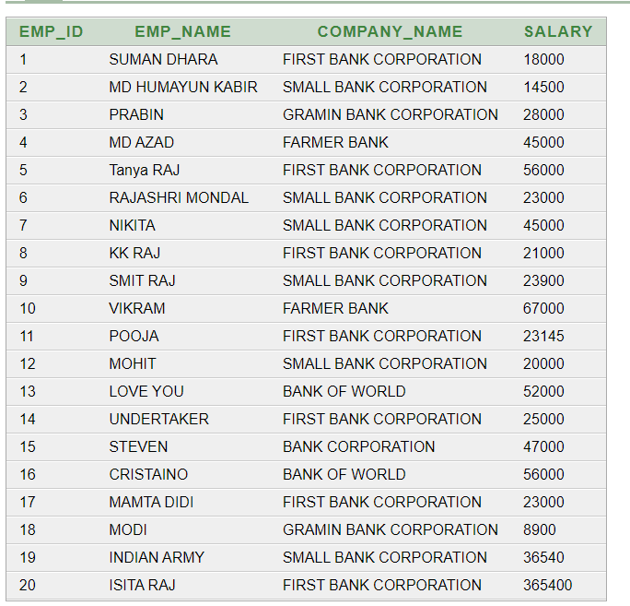

insert into company_91(emp_id , emp_name,city) select emp_id,emp_name,city from employee_91;

update company_91 set company_name=(select company_name from works_91 where company_91.emp_id=works_91.emp_id);

select *from company_91;

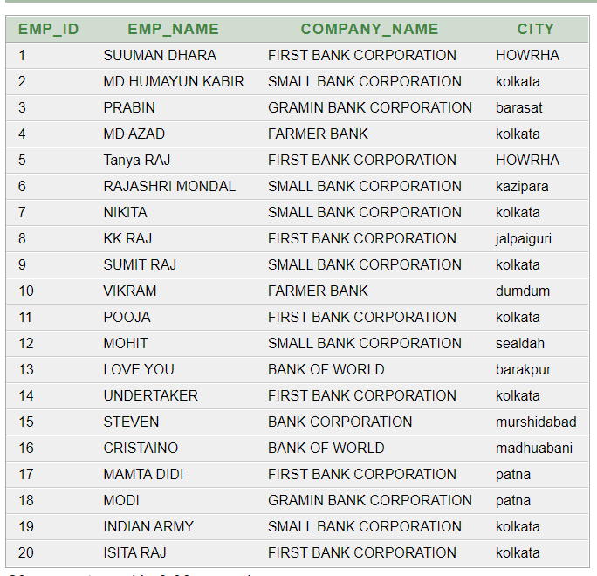

begin insert into manages_91 values(1, 'SUMAN DHARA','SUMIT RAJ');

insert into manages_91 values(2, 'MD HUMAYUN KABIR','MD AZAD');

insert into manages_91 values(3, 'PRABIN','KK RAJ');

insert into manages_91 values(4, 'MD AZAD','SUMAN DHARA');

insert into manages_91 values(5, 'Tanya RAJ','SUMIT RAJ');

insert into manages_91 values(6, 'RAJASHRI MONDAL','NIKITA');

insert into manages_91 values(7, 'NIKITA','SUMAN DHARA');

insert into manages_91 values(8, 'KK RAJ','VIKRAM');

insert into manages_91 values(9, 'SUMAN DHARA','MOHIT');

insert into manages_91 values(10, 'VIKRAM','UNDERTAKER');

insert into manages_91 values(11, 'POOJA','SUMIT RAJ');

insert into manages_91 values(12, 'MOHIT','LOVE YOU');

insert into manages_91 values(13, 'LOVE YOU','POOJA');

insert into manages_91 values(14, 'UNDERTAKER','VIKRAM');

insert into manages_91 values(15, 'STEVEN','MAMTA DIDI');

insert into manages_91 values(16, 'CRISTAINO','STEVEN');

insert into manages_91 values(17, 'MAMTA DIDI','ISITA RAJ');

insert into manages_91 values(18, 'MODI','MAMTA DID');

insert into manages_91 values(19, 'INDIAN ARMY','MODI');

insert into manages_91 values(20, 'ISITA RAJ','MAMTA DIDI');

end

Select *from manages_91;

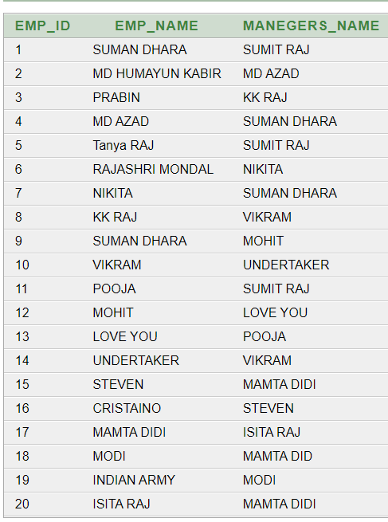

Find the names, street add and cities of residence for all employee who work for ‘ FIRST BANK CORPORATION’ and earn more than >10000 –

select employee_91.emp_name,employee_91.street,employee_91.city from employee_91 ,works_91 where employee_91.emp_name=works_91.emp_name and company_name='FIRST BANK CORPORATION' and salary >10000 ;

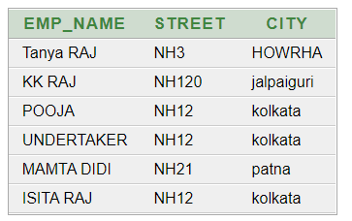

Find the names of all employees in the database who live in the same cities as the companies for which they work—

select e.emp_name from employee_91 e, works_91 w, company_91 c where

e.emp_name=w.emp_name and e.city=c.city and w.company_name =c.company_name; 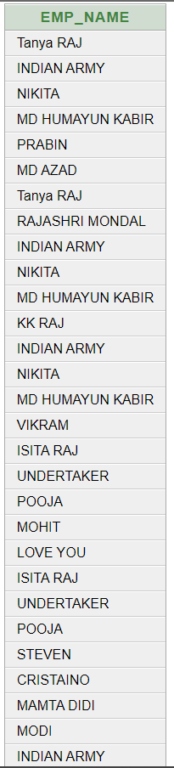

Find the names of all employees in the database who live in the same cities and on the same streets as do their managers –

select p.emp_name from employee_91 p, employee_91 r, manages_91 m where

p.emp_name=m.emp_name and m.manegers_name=r.emp_name and p.street=r.street and p.city = r.city;

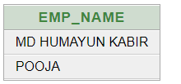

Find the names of all employees in the database who do not work for ‘FIRST BANK CORPORATION’

.Asume that all people wok for exactly one ompany—

select emp_name,company_name from works_91 where company_name<>'FIRST

BANK CORPORATION';

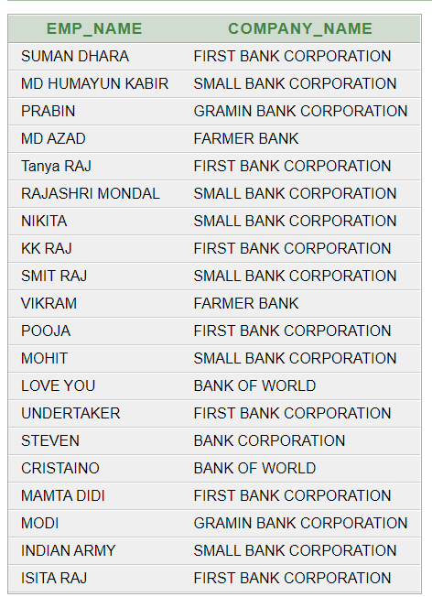

Find the names of all employees in the database who earn more than every employee of ‘small bank corporation’, Assume that all people work for at most one company—

select emp_name ,company_name from works_91 where salary > all(select salary from works_91 where company_name ='SMALL BANK CORPORATION');

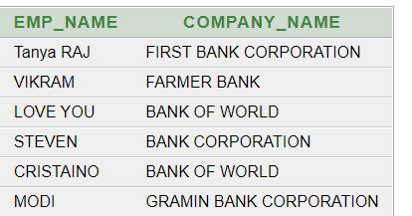

Assume that the companies may be located in several cities. Find all companies located in every cities in which ‘small bank corporation ‘ is located---

select s.company_name from company_91 s where not exists

((select city from company_91 where company_name='SMALL BANK CORPORATION') except

(select city from company_91 t where s.company_name =t.company_name));

Find the names of all employee who earn more than the average salary of all employees of their.Asume that all people work for at most one company—

select emp_name from works_91 t where salary > (select avg(salary) from

works_91 s where t.company_name = s.company_name);

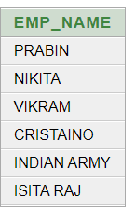

Find the name of the company that has tha smallest payroll—

select company_name from works_91 group by company_name

having sum(SALARY) <= all (select sum(salary) from works_91 group by company_name);

